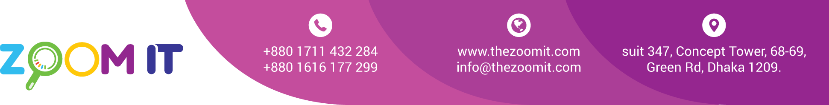

**Bill**

|  |  |
| --- | --- |
| Date | 14/12/2022 |
| INV. NO. | 10129 |

|  |  |
| --- | --- |
| Name | **Gomati Hospital** |
| Address | Nazrul Avenue, Kandirpar, Comilla, Bangladesh |

|  |  |  |  |
| --- | --- | --- | --- |
| **Sl.**  **No.** | **Description** | **task** | **Value in Taka** |
| 1  2 | Domain  Server and Security | Yearly renew bill | 1380  5430 |
|  | | Total | 6,810 |
| Paid |  |
| Due |  |

BANK Details

Ac Name: ZOOM IT   
AC NO: 1782112000003115   
**UCB bank**

Ac Name: ZOOM DIGITAL AC NO: 2228119002279

**Prime bank** Racecourse Branch

**Bkash** 01711432284

Signature